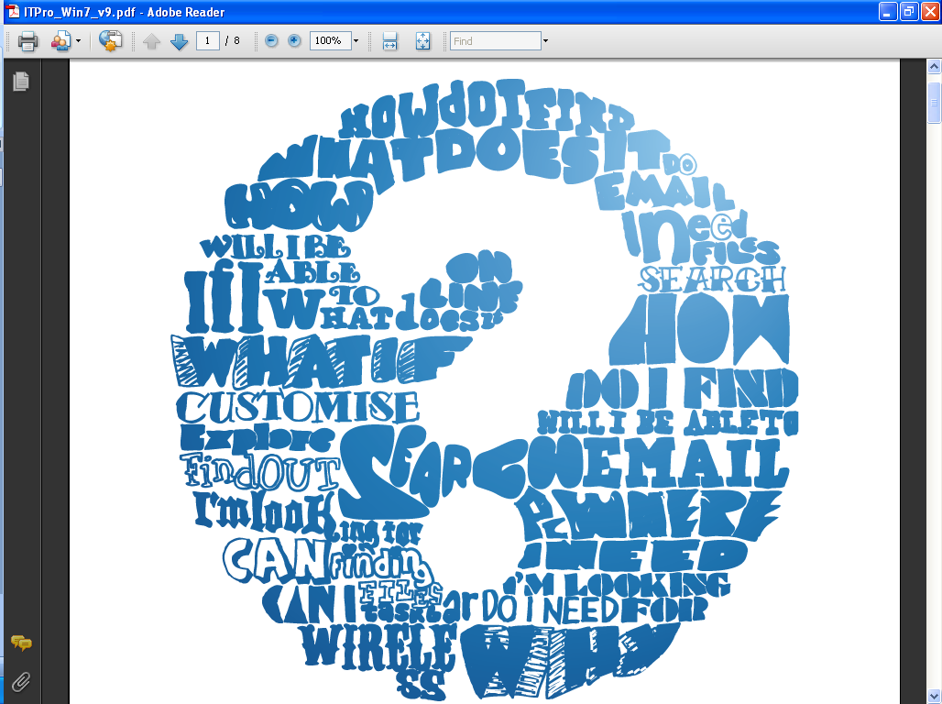

Your Guide to Windows 7

# Where have all my gadgets gone?

Your gadgets are all still there. But instead of them being in the sidebar as they were on Windows Vista, we’ve set them free. So now you can move them around your desktop and even change the size of them.

All you need to do is right-click on the desktop, select gadgets and they will appear. Then you can move and resize them as you want.

## And that’s not all…

Windows 7 features [**Peek**](http://windows.microsoft.com/en-GB/windows7/products/features/aero-peek), which makes your open windows transparent so you can access your gadgets immediately.

# I need to find a file.

# How do I search for it now?

# 

There are now two easy ways to search. One way is to use the search box at the top of any open window. The other is to use the search box in the **Start menu**.

The search starts as soon as you start typing. You’ll immediately see a list of relevant documents, emails, images and music that are on your PC.

Results are now grouped by category and show highlighted keywords and text snippets to make it easier to scan and find the exact one you’re after. You can also filter by date, file type and other helpful categories.

## And that’s not all…

We know that your files aren’t always on your hard drive, so Windows 7 can search external hard drives, networked PCs and **Libraries**, too.

# Help! How do I switch to

# Projector Mode?

We’ve added a keyboard shortcut to make it quick and easy to switch to Projector or Dual-Screen Mode. Just press the **Windows key** and P

If you use a laptop, you can turn on Presentation Mode from the Windows Mobility Center. Doing so will automatically set your Windows Live Messenger status to busy and disable your screensaver, so you can present without interruption.

## And that’s not all…

Using the **Windows key** for shortcuts is a really useful way to work smarter with Windows 7. Here’s some for you to try out:

If you work with dual monitors, move the active window to the left or right by pressing the **Windows key** +SHIFT+LEFT or RIGHT ARROW

Scroll through your Taskbar items by using the **Windows key** +T

Make all windows transparent so you can see your desktop by pressing the **Windows key** +SPACE BAR

If you’d like to minimise all the windows except the one you’re working with, press the **Windows key** +HOME

See other [**Windows key shortcuts**](http://windows.microsoft.com/en-GB/Windows7/Keyboard-shortcuts).

# How can I see everything I’ve got open

# without clicking each individual window?

# 

You can preview all open windows by clicking the **Taskbar** icon. This will give you a thumbnail preview of open files and programs.

To view full-screen, move your mouse over a thumbnail. You can also close windows from the thumbnail view – saving from going into each file or application to do it.

## And that’s not all…

For a quick way of resizing windows, use **Snap**. Simply drag a window to the edge of your screen and it will make it expand vertically, take up the entire screen or appear side-by-side with another window. **Snap** makes reading, organising and comparing documents easy.

And if you need to cut through a cluttered desktop to focus on a single window, click on a window, hold the button and give your mouse a shake. Every open window, except the one you’ve selected, will instantly disappear. Shake again and they’re back.

# How do I quickly get to the files

# and apps I use most?

# 

**Jump Lists** take you straight to the documents, images and websites you use each day. You’ll find them in the **Start menu**, or you can open them by right-clicking on a program icon on the **Taskbar**.

What you get in a **Jump List** depends on the program. A **Jump List** for **Internet Explorer 8** will show frequently visited websites and **Microsoft Office** will show the most frequently opened Office documents. If your **Jump List** is missing a favourite, right-click the file and select [***Pin to taskbar***](http://windows.microsoft.com/en-GB/windows7/Pin-a-program-to-the-taskbar).

## And that’s not all…

[**Libraries**](http://windows.microsoft.com/en-gb/windows7/products/features/libraries)make it easy to find and organise files scattered across your PC, even if they’re saved on external drives.

A **Library** brings files together in one place, regardless of where they’re actually stored, so you spend less time searching.

# How can I get help from my IT department

# without them being able to see my screen?

# 

**Problem Steps Recorder** lets you capture screenshots and add comments to create a visual record of the issue you’re having. You can then save the steps in a file and send it to your IT department.

Here’s how:

1. Click **Start** and type **Problem Record** in the search bar
2. Select **Record steps to reproduce a problem**
3. Click **Start Record**, then proceed through the steps to recreate the issue you’re having
4. If you want to add any text to support the screenshots, use the **Comment** feature to save it into the file
5. Click **Stop Record** when you have the information
6. In the **Save as** dialog box that appears, type a file name, then click **Save**. The file will be saved with a .zip file extension, which you can email to your IT department.

## And that’s not all…

**Windows Troubleshooting** can automatically pinpoint and fix more than a dozen common issues such as **being unable to print** **or connect to the Internet**. This saves you from having to diagnose problems yourself or waiting for the IT department to help.

You can find **Windows** **Troubleshooting** in the **Control** **Panel**. Set it to automatically perform scheduled maintenance, including cleaning up temporary files or scanning your hard disk for errors. And if something needs to be looked at, you’ll get a notification in [**Action Center**](http://windows.microsoft.com/en-gb/windows7/products/features/action-center).

More ways to make

everyday tasks easier

We hope you found this Guide useful and that with its help, you’ll find everyday tasks quicker and easier with Windows 7.

There are lots more ways you can simplify tasks and do more with Windows 7, you can [***find out about them here***](http://windows.microsoft.com/en-GB/windows7/products/features).