Using GotoMeeting

GoToMeeting is a Web conferencing tool that allows you to meet online rather than in a conference room. It enables customers and prospects to view any application running on our PC in real time from the convenience of your PC or Mac.

When you receive an email inviting you to a GotoMeeting presentation, follow the steps shown below to join the meeting.

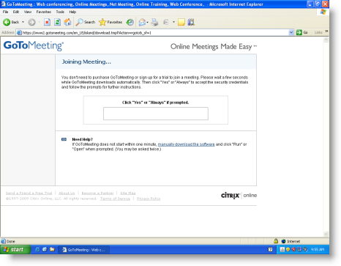
Click the GotoMeeting link in the email or paste the URL into your browser.

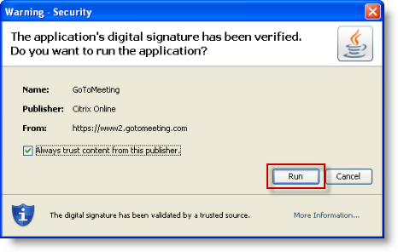
After a few seconds a security warning message will appear. Click on the Run button

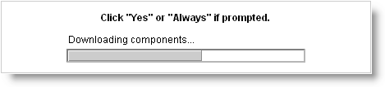
The GotoMeeting components will start to download.

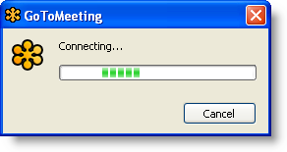
Once all the components are downloaded, the connection to the meeting will start.

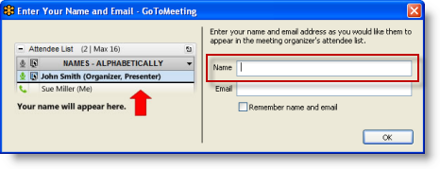
Please enter your name when prompted. Your email address is optional but will be useful for us to follow up after the presentation.

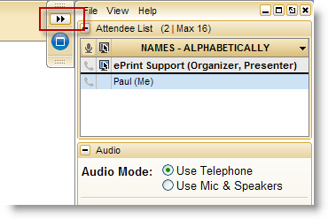
The GotoMeeting sidebar will appear once you have joined the meeting. Minimize the sidebar by clicking on the button.

