A Hillwalking Story

The sun peeked over the horizon, casting a golden glow across the rolling hills. Emma tightened her laces, slung her backpack over her shoulders, and took a deep breath of the crisp morning air. Today was the day she had been waiting for: her first solo hill-walking adventure.

The path ahead wound through a patchwork of grassy slopes, rocky outcrops, and occasional clusters of trees. With each step, Emma felt the weight of the city slipping off her shoulders. The gentle rustle of the wind and the distant call of birds were her only companions.

As she climbed higher, the terrain became steeper and more challenging. Loose stones shifted beneath her boots, and she had to pause occasionally to catch her breath. But the view made every effort worthwhile. From the top of the first ridge, Emma could see miles of unspoiled countryside, the valleys below blanketed in mist that shimmered like silver under the sunlight.

Midway through the ascent, Emma reached a plateau dotted with wildflowers. She decided to take a break, pulling out a thermos of tea and a sandwich. Sitting on a flat rock, she savoured the simple meal while watching the shadows of clouds dance across the hills. For the first time in weeks, her mind felt clear and uncluttered. She took out her journal and sketched the scene, capturing the vibrant colours and intricate patterns of the wildflowers. It was a moment of stillness she wanted to remember forever.

Continuing her climb, Emma encountered a small stream cascading down the rocks. She stopped to refill her water bottle and marvelled at the clarity of the water, so different from the murky rivers back in the city. A family of deer darted through the trees nearby, their presence a fleeting reminder of the wilderness she was surrounded by.

The final stretch of the climb was the most demanding. The path narrowed, and the wind grew stronger, tugging at her jacket. She could see the summit now, so close yet still requiring her full focus. Emma steadied herself, planting each step firmly, her heart pounding with exertion and anticipation. When she finally reached the summit, she let out a triumphant laugh. The panoramic view was breathtaking: endless layers of hills fading into the horizon, their hues shifting from deep green to soft blue.

Emma stood there for a long time, feeling a profound sense of accomplishment. The journey had been more than just a physical challenge; it was a reminder of her resilience and her connection to the natural world. She found a flat spot on the summit and laid back, watching the clouds drift lazily across the sky. She thought about the people who had climbed this hill before her, each bringing their own dreams and struggles. In that moment, she felt a sense of belonging to something greater.

As the day wore on, Emma decided to set up camp just below the summit, where the wind was less fierce. She unpacked her small tent, securing it against the rocky ground. Once it was set up, she gathered some dry twigs and kindling from the nearby scrub to start a small campfire. The warmth of the fire was a welcome comfort as the temperature began to drop.

For dinner, Emma unpacked a lightweight cooking kit and prepared a simple but hearty meal of pasta and vegetables. The smell of the food mingled with the crisp mountain air, making her mouth water. She ate slowly, savouring each bite while watching the horizon. The sun was sinking lower, painting the sky with streaks of orange, pink, and purple. It was a sunset unlike any she had ever seen, and she felt a deep sense of gratitude to be witnessing it from this serene spot.

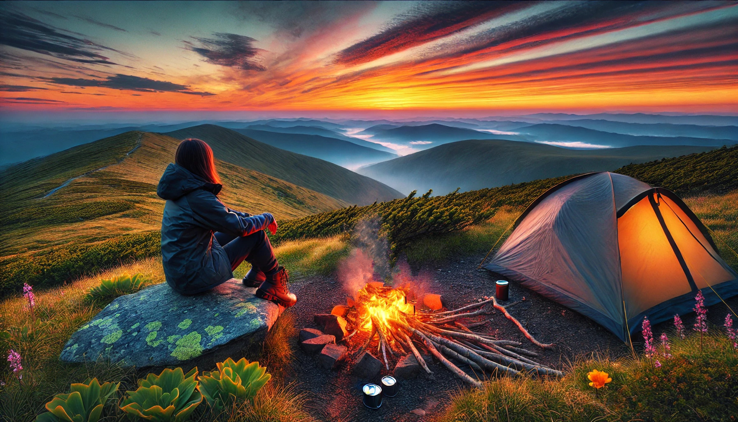

As twilight fell, Emma brewed herself a cup of hot chocolate and wrapped herself in a warm blanket. She sat by the fire, gazing up at the emerging stars. The stillness of the night was broken only by the occasional rustle of the wind and the distant hoot of an owl. She felt completely at peace, her worries left far behind in the valleys below.

Before retreating to her tent, Emma took one last look at the night sky, now a canopy of glittering stars. She made a silent promise to herself to seek out more adventures like this, to embrace the beauty and challenges of the natural world.

The next morning, Emma woke to the soft light of dawn. She packed up her camp and began her descent, the hills around her bathed in golden light. The experience had left her with a profound sense of connection and clarity. She knew this wouldn’t be her last hill-walking adventure. She had discovered a new passion, one that filled her with both peace and purpose, and she couldn’t wait to plan her next journey.